**Underlying Assumptions**

The product lifecycle is agile in nature and due to the budget and time constraints, the teams tend to make some assumptions to continue to push forward. Making assumptions is an important part of the problem solving and ideation process but there is a need to validate these assumptions through user research since these assumptions play a role in decision making process. This process helps build empathy for the end users, listen carefully to what they have to say, and build products that meet their validated unmet needs rather than developing a product which serves the needs of the users according to our beliefs of what the user needs are.

Multiple assumptions were identified by making use of a matrix on a whiteboard as follows:

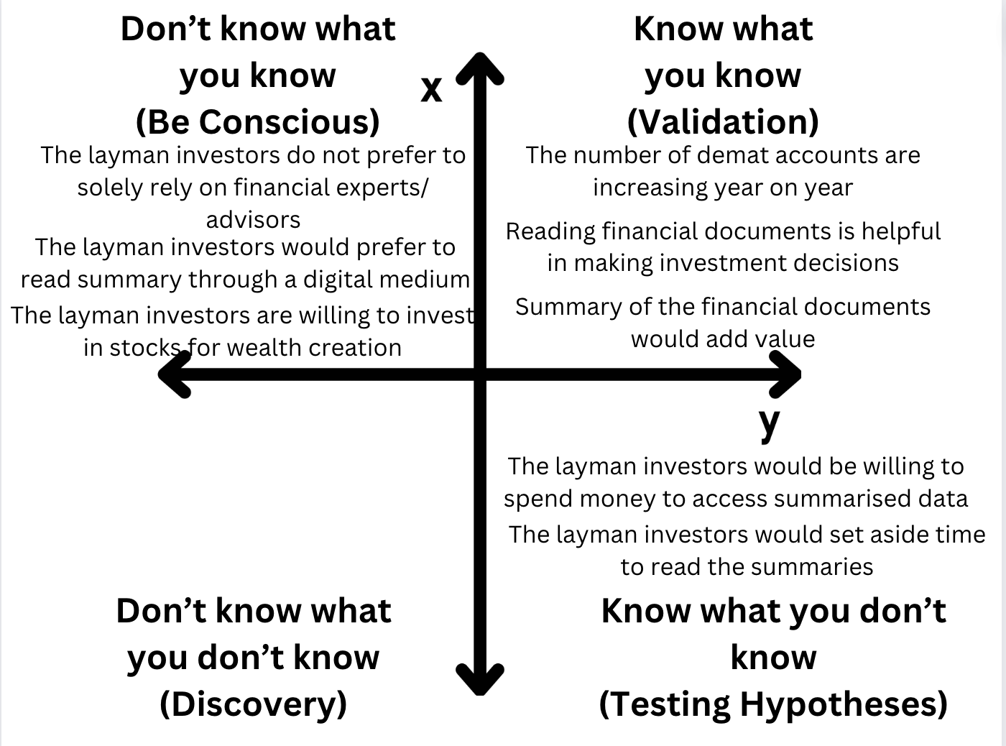

Fig: Role of user studies

After the assumptions were identified, they were ranked in the order of risk to focus our user research to find answers to pressing questions on which our problem statement was based. This was a risk management tactic to quickly ascertain whether the problems we were trying to address are the needs of the users or not. The following three high risk assumptions were chosen to be tested through all the following stages:

* The people are interested in setting aside time and putting efforts to read through the documents
* The time of the users will be saved if they read the summary instead of the whole document
* The summary of the documents would hold relevance in making informed investment decisions

The strategy adopted for testing these assumptions is as follows:

* An effort was made to interview as many customers as possible
* The interview style followed was exploratory so that the customer’s opinions and viewpoints were not influenced
* Interview consisted of a member of the team who prompted questions and another team member who took note of the insights from the conversations as a scribe
* A list of over 20 questions were prepared to help serve as the guideline during the interviews
* The questions were segmented-some of the questions were general for everyone while some others were framed for the customers with background in finance and customers who did not have the fundamental knowledge of financial jargons in order to facilitate the discussion better
* An effort was made to find patterns in the responses from the interviews to ascertain those as representative of the user segment
* The patterns identified were then leveraged to discard or accept the assumptions that were made

**Prototyping**

To give the customers an idea about how the solution would look like, a digital prototype was created. In this stage:

* The questions that we wanted to be answered through prototype testing were identified
* The basic features that would help answer the questions were selected and all the good to have features were placed out of scope of this stage
* Focus was placed on the user needs to come up with a design which was easier for the users to navigate through

The questions that we wanted to be answered through our prototype are as follows:

* Does the user have the understanding of different financial documents used for summarisation?
* Which documents would the user be more interested in selecting for summarisation?
* Does the user find the flow of navigating through the web application intuitive?
* Does the user have an understanding of the sectors a company belongs to?

These questions were framed to test our assumption that the user knows what document(s) they want to read and is interested in reading the summary of the documents to make investment decisions.

A paper prototype was created initially which was later transformed into a digital prototype using Figma. The digital prototype was the chosen prototyping approach because:

* The idea is a web application and thus, a digital prototype simulated the vision of the solution better
* The customers who did the prototype testing were outside our campus and thus, sharing the link of the prototype ensured accessibility for them to rest the prototype easily
* A high-fidelity prototype could be produced with low efforts which enabled gathering of authentic user performance data quickly

The user flow of the prototype is as follows:

* The user has the option to select among different kinds of reports. These include Annual Reports, IPO documents, and Others.
* After the user makes the choice of the document, they are directed to select the type of industry and the company for which they need to generate summary
* After submitting their selection, the user can view the key parameters that can help make informed investment decisions as well as the summary of the document
* The user also has the option to view the whole report

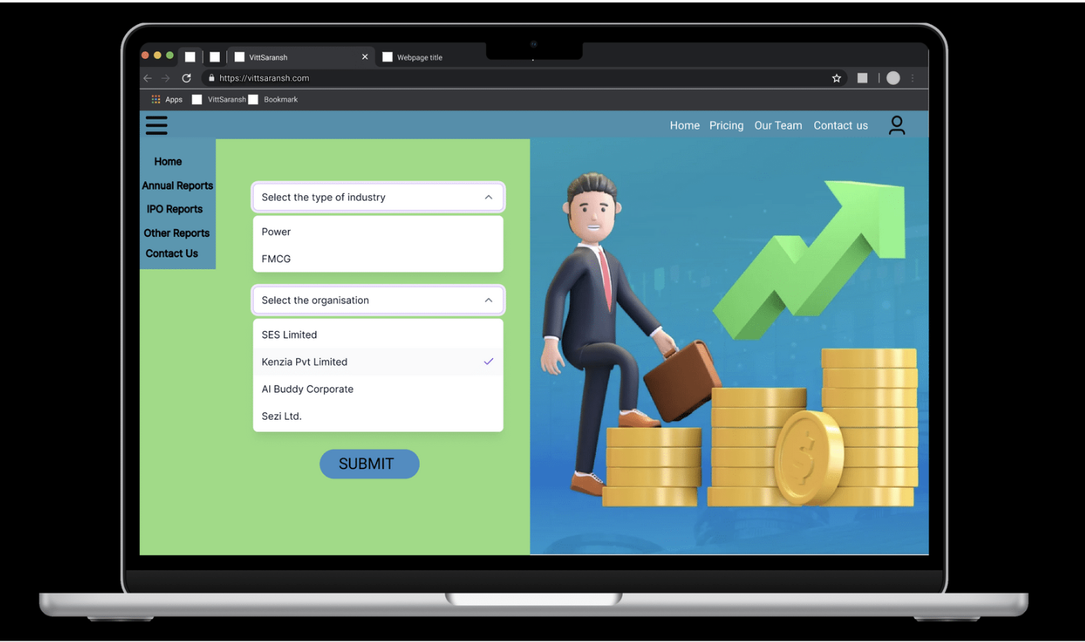

Fig: The home screen where the user makes the choice of the document

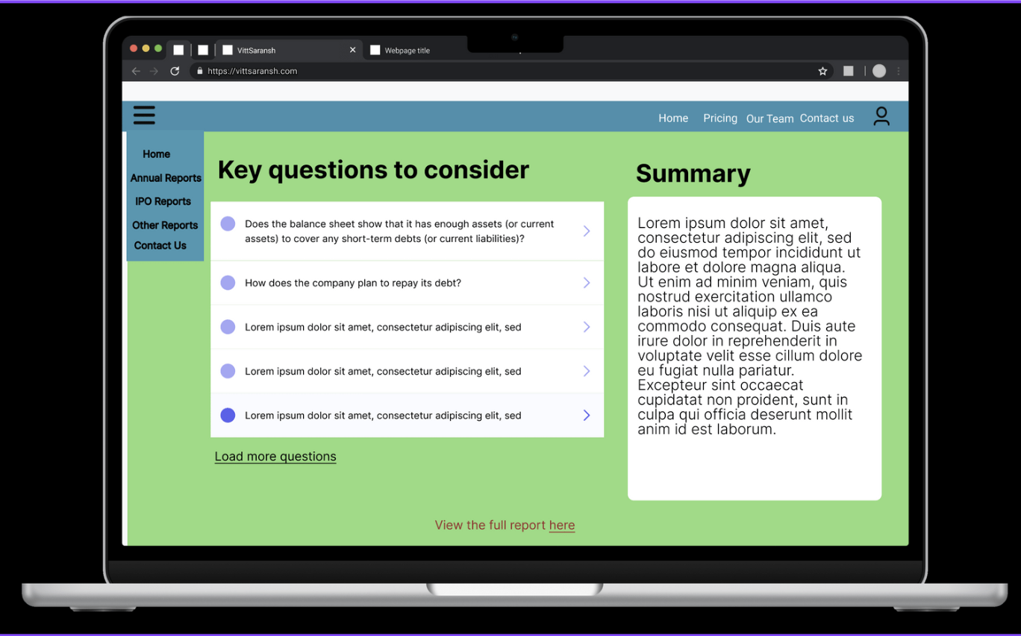

Fig: The screen displaying the summary and key questions to consider

After the prototype was created, the strategy for conducting the prototyping testing was created:

* The users will be given a background about the problem the prototype is supposed to address
* The user will then be allowed to interact with the prototype as they wish
* Minimal effort will be placed to guide the users in order to accurately capture their behavior
* One team member would take note of the user behavior to understand their user flow while another team member will get user feedback through a verbal discussion
* The feedback will be read in a succinct manner towards the end of the testing to validate that we understood their feedback correctly

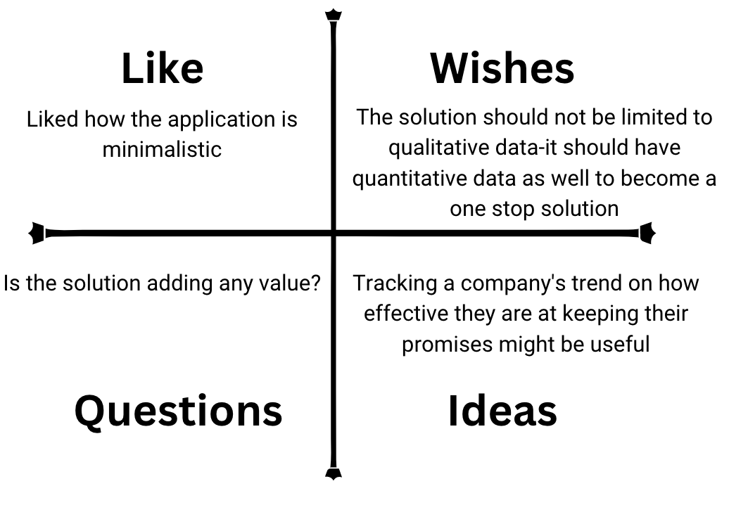

Fig: The outcome of one of the prototype testing

More prototype testing is currently underway and the insights from the documentation of these will be used to make the experience for the users better by finalizing the improvements in the prototype that will be incorporated in the following iteration of prototyping and prototype testing.